Basics of database systems

**Project – Database design**

Lappeenranta-Lahti University of Technology LUT

Software Engineering

Basics of database systems

Spring 2023

Table of contents

Table of contents 1

1 Definition 2

2 modeling 4

2.1 Concept model 4

2.2 Relational model 5

3 database implementation 6

# Definition

**Bicycle database: for the new buyer**

When choosing the right bicycle for you there are thousands of options on bikes. When you start to look for differences between candidates there are multiple things to consider such as suspension, tire type, wheel size, weight, materials and many more. I am creating a database that allows you to narrow down possible new candidates based on your desired options.

The five queries I am going to make are:

Downhill bike: >180mm suspension, no weight limit, maximum 9 gears, 4-piston breaks.

Trail bike: >120 mm suspension, maximum of 15kg, At least 10 gears.

XC-bike: 100-120mm suspension, <12kg, 11-12 gears, 29’ wheels.

Gravel bike: 25-45c tires, disc brakes, flared bars

Road bike: 20-35 c tires, dropper bars, weight <10kg.

# modeling

## Concept model

**Figure 1:** ER model

The Bicycle entity has the main information regarding it. It has only one type of relationship “Has”, but it has many cardinalities. Most importantly the Bicycle can only have single connection to the other entities with the exception being wheels. It can have one or two relationships with wheel depending on are the wheels same in the front and back. This will be addressed in the relational model.

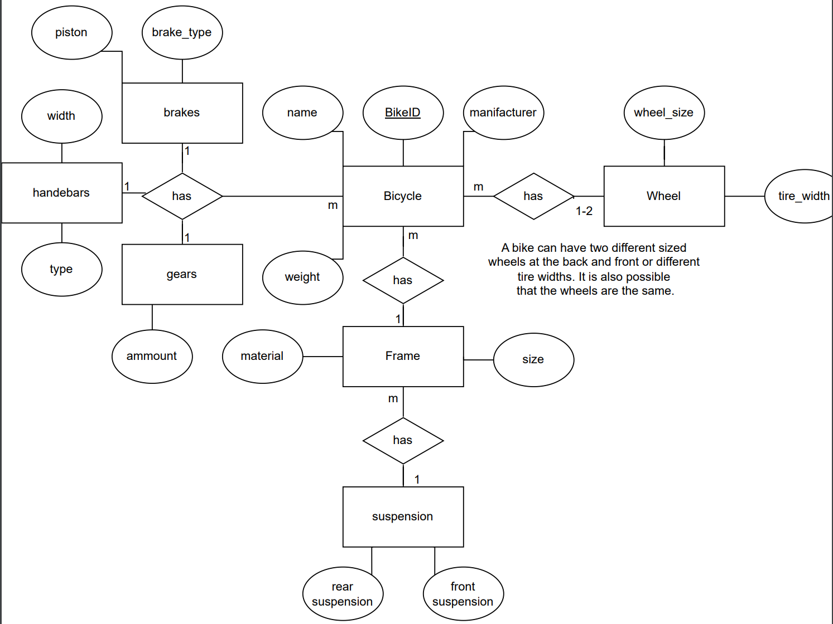

## Relational model

**Figure 2:** Relational modelfrom the ER model

Figure 2 shows the relational model that has been created based on the ER model. Due to the N:M relationship, an interim relation was created between Bicycle and Wheel entities.

Also, another interim relation Setup was made to connect Handlebars, Gears and Brakes.

# Database implementation

* **Bicycle**
  + Manufacturer, name , BikeID and weight cannot be null (NOT NULL)
  + Weight must be above zero (CHECK)
* **Frame**
  + Foreign key references to Bicycle.BikeID and Suspension.SuspensionID and the make a composite key
* **Suspension**
  + SuspensionId, front or back suspension cannot be null (NOT NULL)
  + Front and back suspension must be 0 or more and default to zero(CHECK)(DEFAULT)
* **Wheel setup**
  + Composite key is formed from foreign keys that reference to Wheel and Bicycle.
  + ON UPDATE CASCADE
* **Wheel** 
  + Wheel size and tire width cannot be null (NOT NULL)
* **Setup**
  + Primary key is a foreign key referencing Bicycle.BikeID
  + Other foreign keys reference to Gears, Handlebar and brakes
* **Brakes**
  + If brake_type is set to ’rim’ the piston must be zero (CHECK)
* **Handlebars**
  + Type and width cannot be null (NOT NULL)
* **Gears**
  + Ammount cannot be null or less than one and default is one (NOT NULL) (CHECK) (DEFAULT)